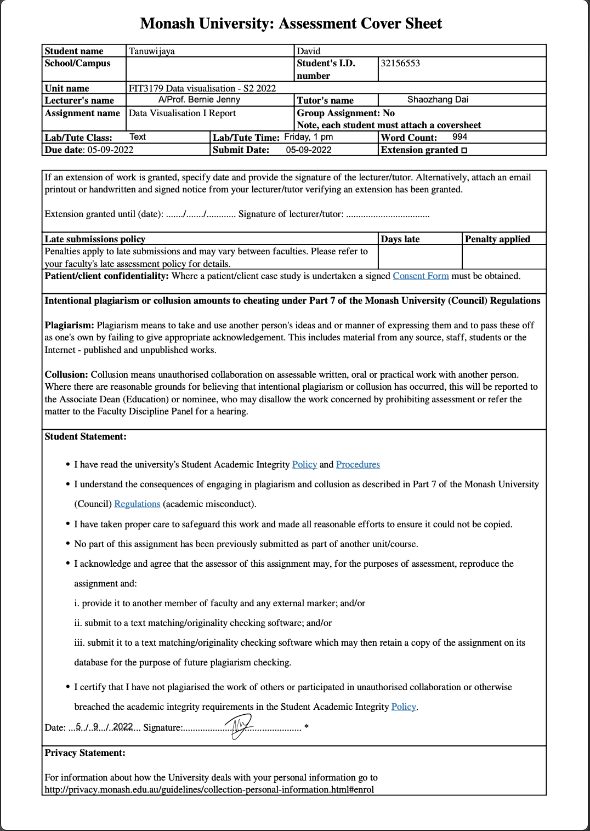

**Assignment 2: FIT3179 Data Visualization**

**Singapore’s Public Transport System**

[**https://dtwjy.github.io/Visualisation2/**](https://dtwjy.github.io/Visualisation2/)

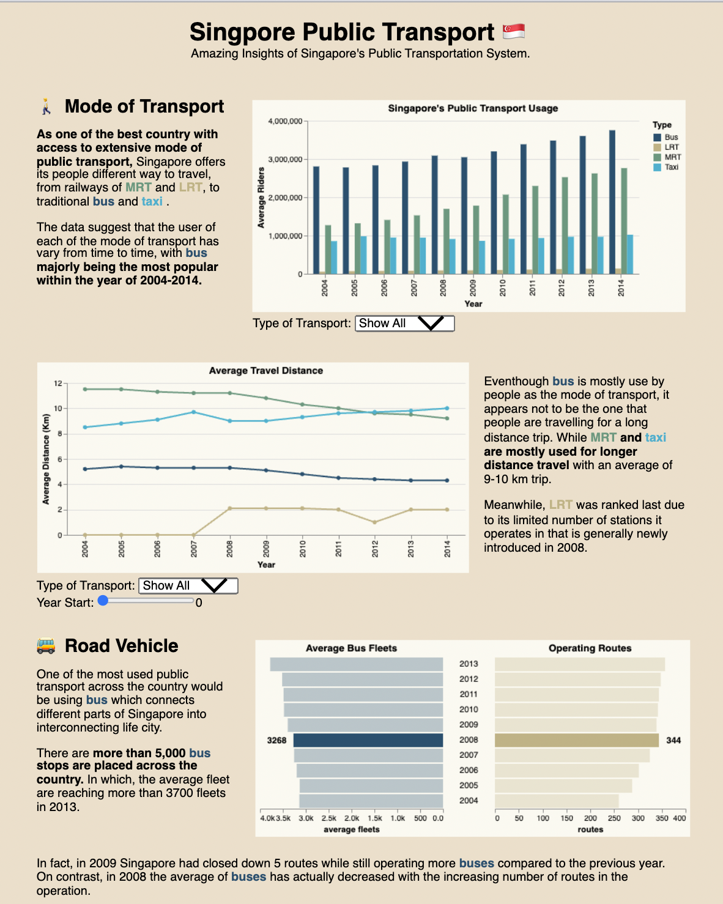

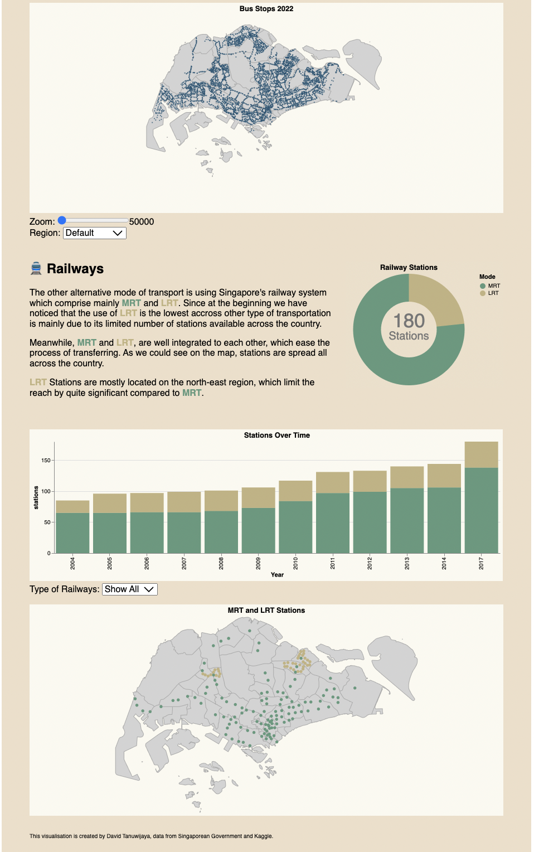

Name : **David Tanuwijaya**

Monash ID : **32156553**

Tutorial : Wednesday, 1 PM

Word Count : (excluding figure caption, appendixes, and references)

**Why and Who**

The visualisation aims to present and depict interesting facts about Singapore’s public transport system which are recognised as one of the best systems in the world (Camille Tillman, 2022). Overall, the fact was displayed in various types of graphs and statistical figures to view the data from different perspectives. The visualisation is mainly divided into 3 different sections of the broad overview/introduction, road vehicles, and railways system. The aim is to inform reader to know more about Singapore’s public transport system.

**What**

The data was derived from the Singapore’s Government of Public Transport department and other supportive public dataset from Kaggle. Most graphs are having a table type dataset, with combination of quantitative attributes (coordinates of the bus stops and train stations) with categorical variables assessed for each stations’ name and mode of transportation. Some of the information are presented in an ordinal way such as year and count data.

**Why and How**

1. Public Transport Usage

As to the introduction of the topic on the country’s public transport system, we could assess the significancy based on the qualitative attribute of the count of average riders of public transport users regarding different type of transportation available, in this case MRT, LRT, Bus, and taxi. Colour are used to categorise each rider to different mode of transport.

User could select specific mode of transport evaluate the exact number and analyse growth/trend of the number of riders using the filter function below.

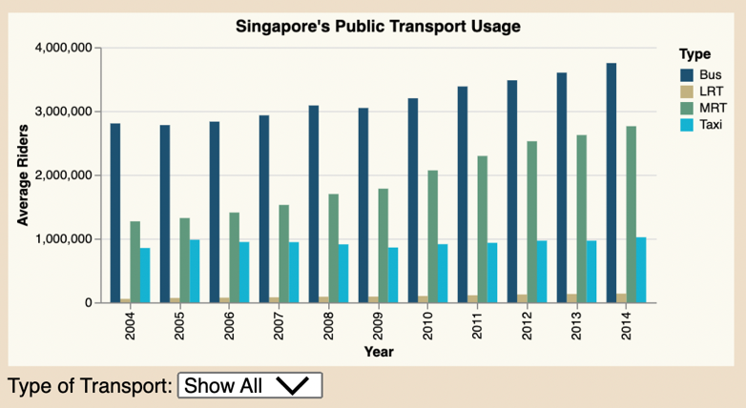

Figure 1: Singapore’s Public Transport Average Riders

1. Demanded Education Sector

Line chart is used to easily capture the changes happened over time on the average travel distance made by passenger for each different type of transportation. Color is used consistently to represent the different mode of transport as a categorical variable. Y axis would be the average travel distance in Km as quantitative attributes. Interactive slider and filter drop down menu are available for user to further analyse the data based on the type of transportation used or simply the starting year of the data.

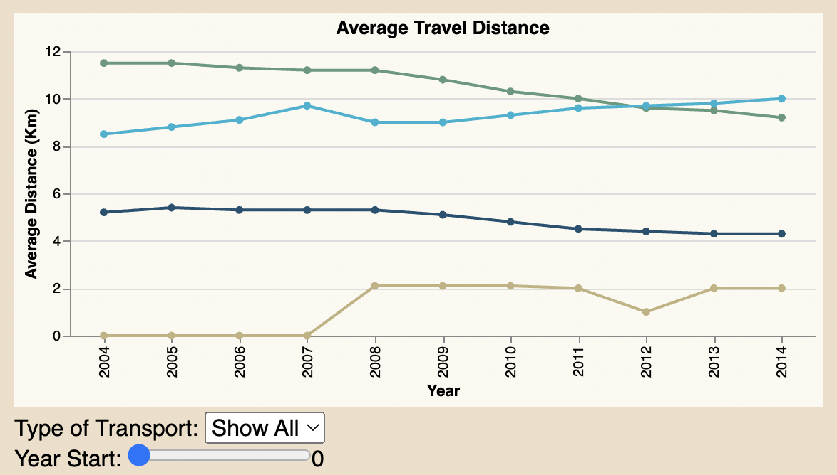

Figure 2: Line chart of average travel distance by each mode of transportation from 2004-2014

1. Moving to the next part of the visualisation, where we take a closer look into the road vehicle options of Bus and Taxis. This segment mainly demonstrates how the operation of bus lines are improved every year from year to year, with some interesting facts worth to analyse.

In this case, the double-sided bar chart compares the number of average bus fleets and the actual number of routes in operation during a particular year. Turns out, in 2009, there is an increase in number of bus fleets, while the operating routes are decreased. Hence, it might indicate inefficiency in the operation of bus fleets that appear to increase the number of buses used or simply to increase the performance up from the prior year of 2008 where a significant number of routes increase has been erupted.

Both graphs, y axis contains the year as a nominal attribute, while x axis provides a quantitative measure of both different values of average fleets and number of operating routes. Highlighted value is being on the 2008, where an adverse changes to the operation of the bus routes and fleets as mentioned above.

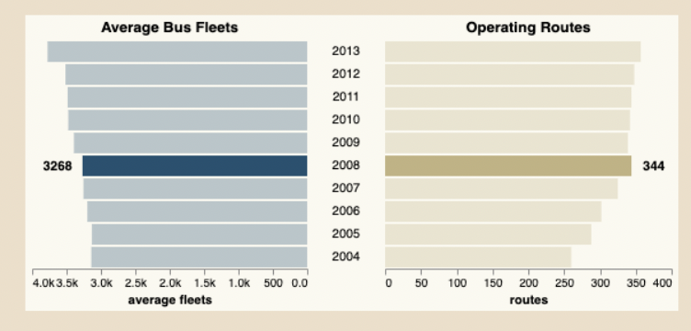

Figure 3: Average Bus Fleets vs Operational Bus Routes over the years

1. The visualisation depicts the distribution of public transport access in Singapore for all types of transport. We could see that the distribution of bus stops is generally spread all across the country, while for LRT has only be able to cover few stops in mainly the north-east part region.

In this case, data was mostly being categorical with a coordinate quantitative value in it that is being mapped to the topo-jason object. The colour was used accordance to the type of transportation being review throughout the report. Since the map for the bus stops has mainly being populated and dense, the zoom feature allow user to depict and focus more into a specific region of the country.

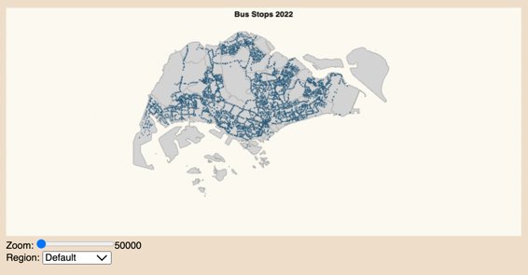 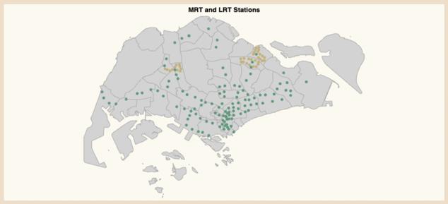

Figure 4: Map projection of the location of public transport across the country (MRT, LRT, Bus)

1. The next section of the visualisation explains more about the railway system of Singapore’s excellent service of MRT and LRT. Donut chart is used to compare the number of stations of MRT and LRT, which in this case was proven to be significant. This may be since LRT is a new transportation mode being introduced to the country from 2008, which makes MRT to have a head start building their stations and lines.

The colour signifies the MRT and LRT (categorical), while the size of the donut represents the proportion of stations count (quantitative attributes). Additional annotation was made in the centre of the donut to give a quick total of how many stations are there in the country.

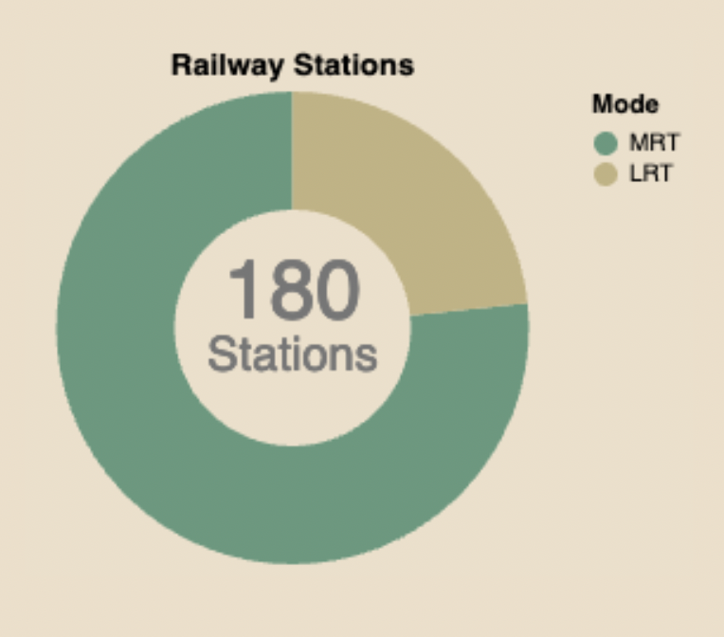

­­

Figure 5: Proportion of number of MRT and LRT stations in 2017

1. The visualisation of the stacked bar chart is used to continue the storytelling part of the previous donut chart, given the number of station changes over the year. This provide user more information of how the railway line has been developed for the past years. Y axis being the quantitative attributes of the station count, while x spreads year as part of the categorical, ordinal attributes. A filter button is provided to be able to select a particular type of railway type to be displayed individually as a bar chart. Colour is again used to differentiate the type of public transport selected.

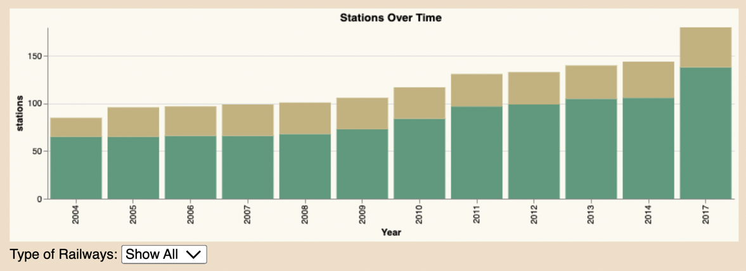

Figure 6: Proportion of LRT and MRT stations across the year of 2004 - 2007

**Dashboard Design**

The overall layout of the visualisation is mainly divided into 3 big rows and 3 columns with sub segmented part of introduction, road vehicles, and railways section. All the section was explained with at least one visualisation and graph description. Text arranged symmetrically and consistent layout throughout.

The visualisation majorly uses the earthy colour scheme of green, light grey, brown, blue, and light blue to capture the natural part of the transportation which supposed to be part of humans need as a social wellbeing. Overall, the colour is consistent throughout the visualisation with clear usage of highlighted crème panel background to display each of the visualisation as a container. Colours are also used in some of the text descriptions to indicate the relationship between the data and its description.

Consistent Helvetica typeface is being used as the main font of the visualisation to give a clear, easy to read appeal. Text weight, size, and colour differentiation are used to emphasize important information related to the relevant graph. Graphical elements such as emojis are used in the title of the visualisation and sized accordingly to create visual cue and aesthetic reasons.

The storytelling aspect is one of the main objectives of the infographic, guiding the user readability and understandability of the infographic from start to end. The overall infographic is strategically placed to be read from left to right, with guided text assisting the user to understand the context the information and informative tooltip when hover across different visualisation.

**Appendix**

Five Design Sheet

Sheet 1

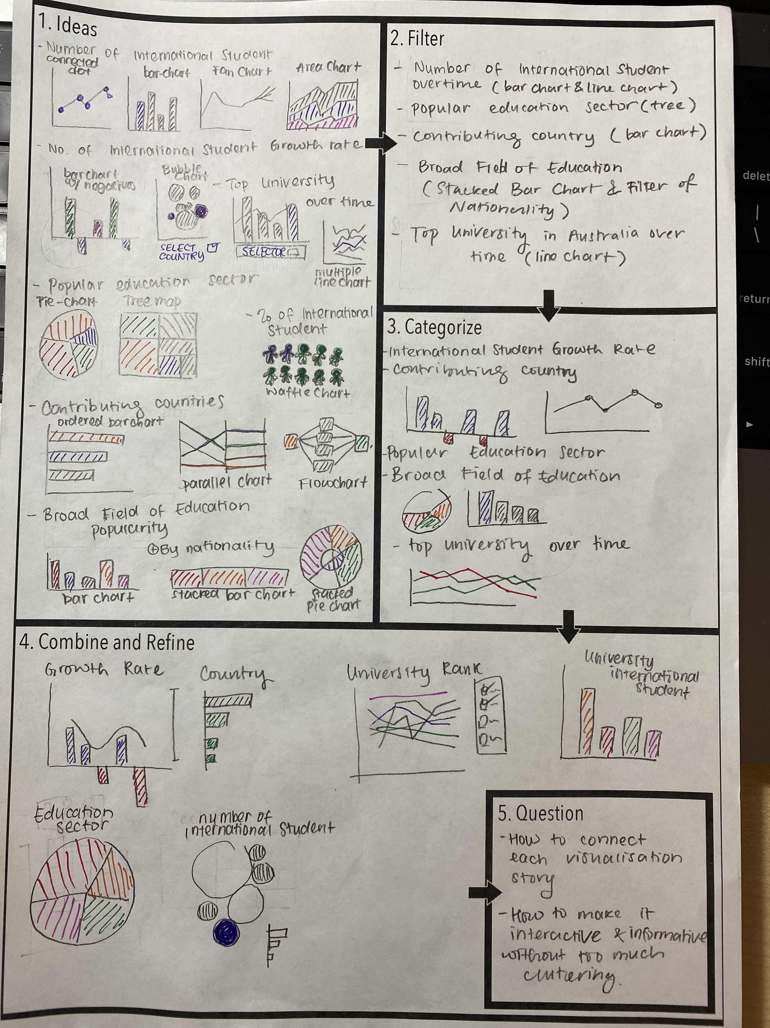

Sheet 2

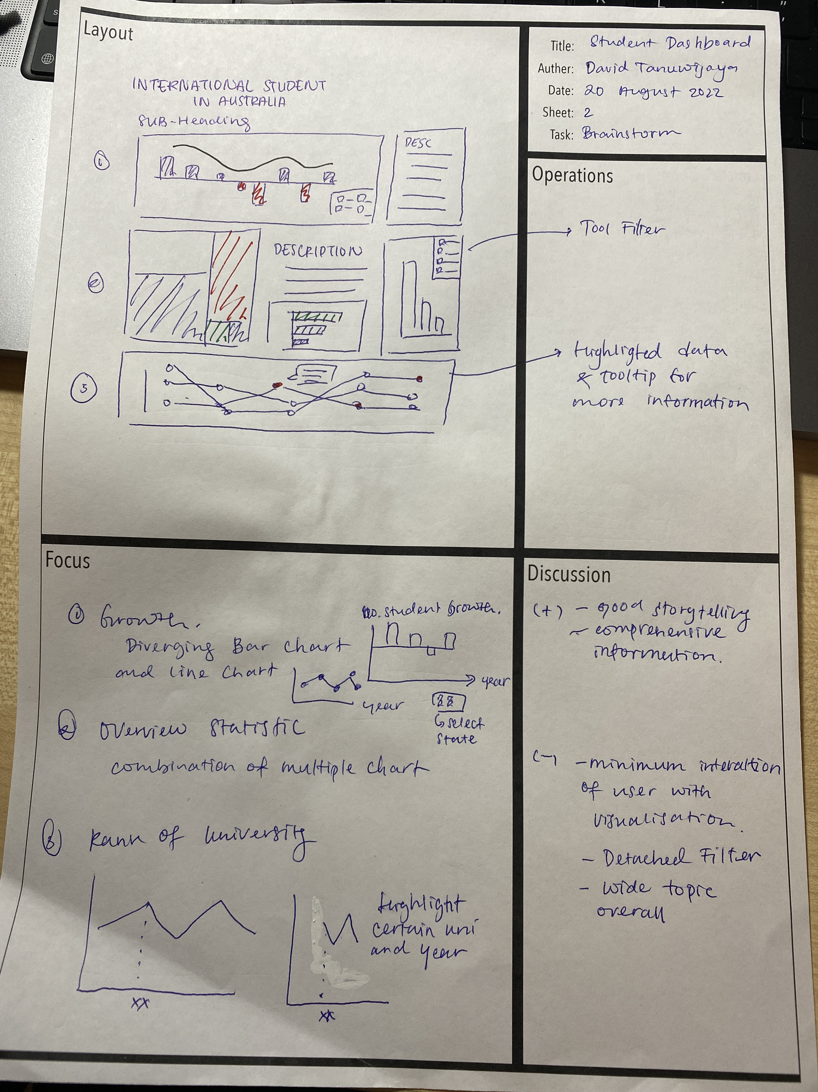

Sheet 3

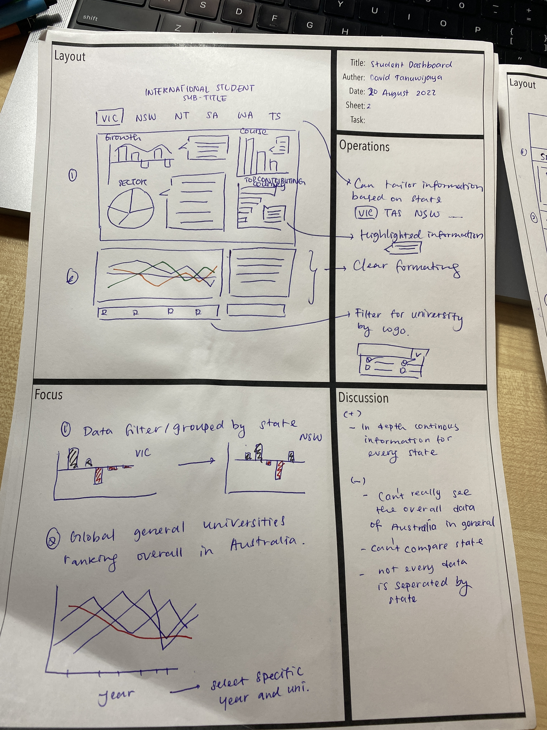

Sheet 4

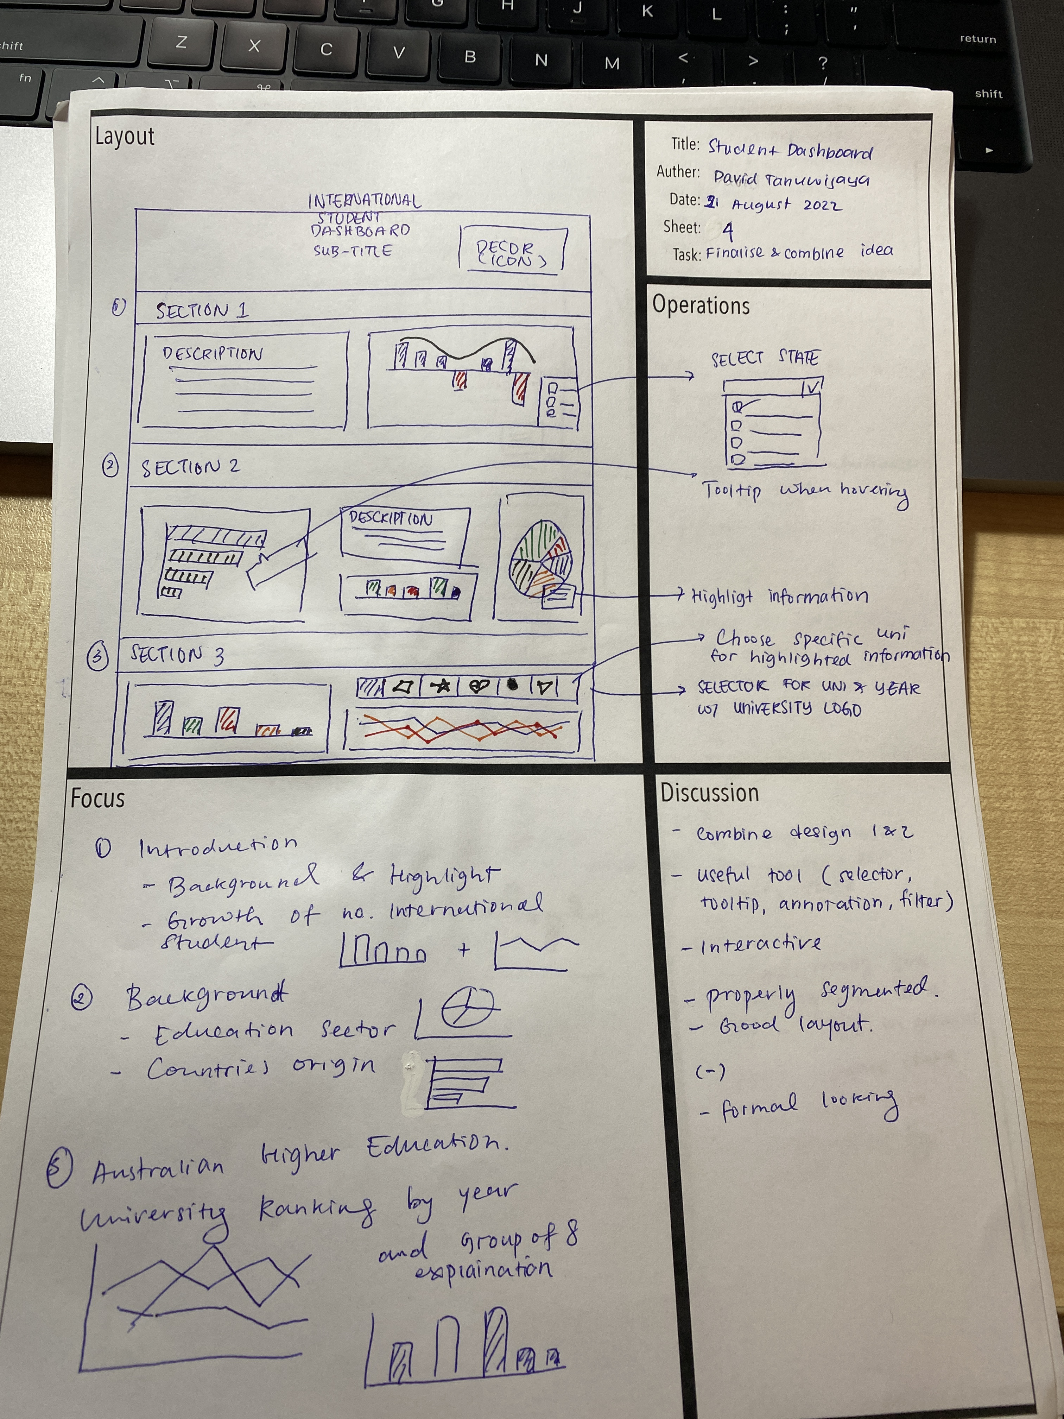

Sheet 5

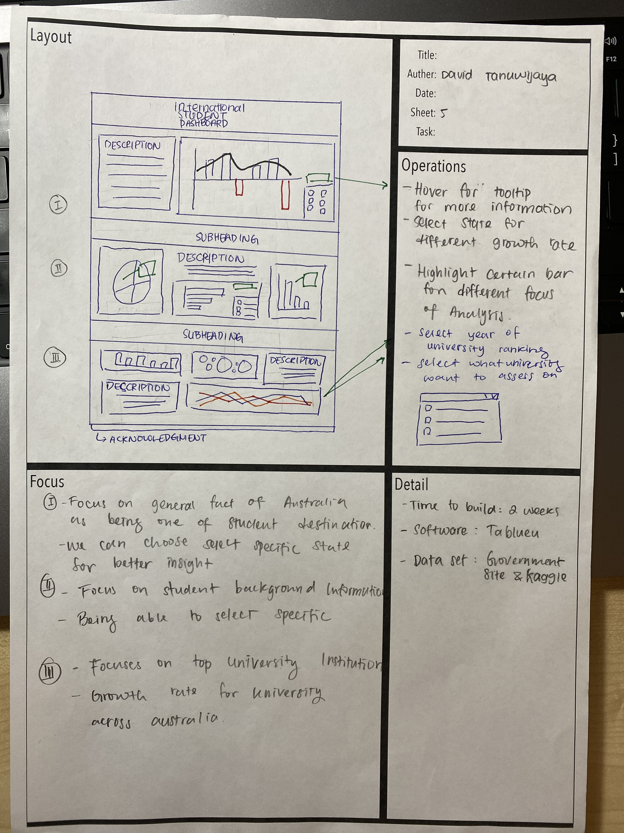

**References**

<https://www.rapidmts.com/singapores-transport-system/#:~:text=A%20popular%20travel%20website%20based,up%20to%200.9%20m%20tall>.

<https://www.kaggle.com/datasets/yxlee245/singapore-train-station-coordinates>

<https://observablehq.com/@cheeaun/list-of-bus-stops-in-singapore>

<https://data.gov.sg/dataset>